Contents
- Step 1: Access the Client Portal
- Step 2: Choose Login or Register
- Step 3: Select Registration
- Step 4: Complete the Registration Form
- Step 5: Verify Your Email
- Step 6: Set Your Password
- Step 7: Register Your Phone Number
- Step 8: Finalize Registration
- Step 9: Confirm Account Creation

Step 1: Access the Client Portal
- Open your browser and navigate to the “https://apiclientportal-dev-app.azurewebsites.net/ ” by entering the website URL.
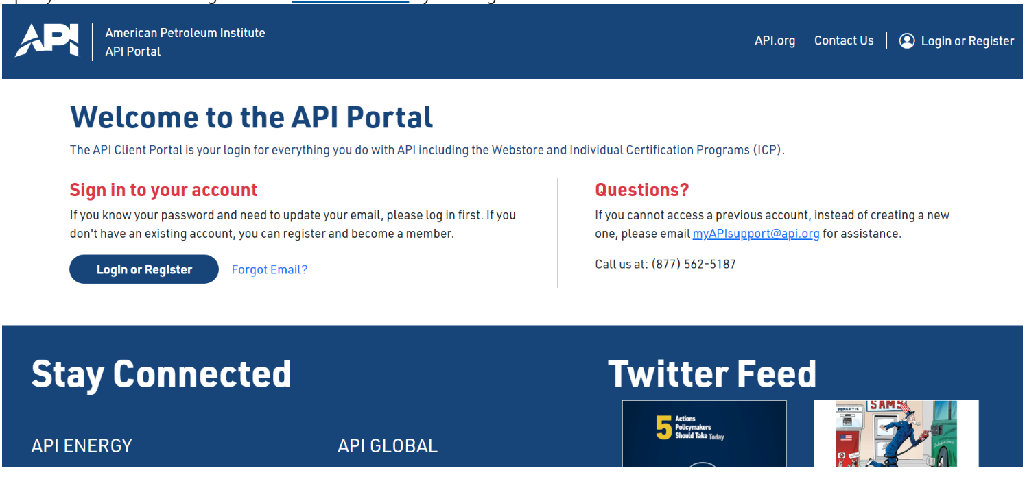

Step 2: Choose Login or Register
- Click the Login or Register button located in the top right corner to proceed to the login or registration page.
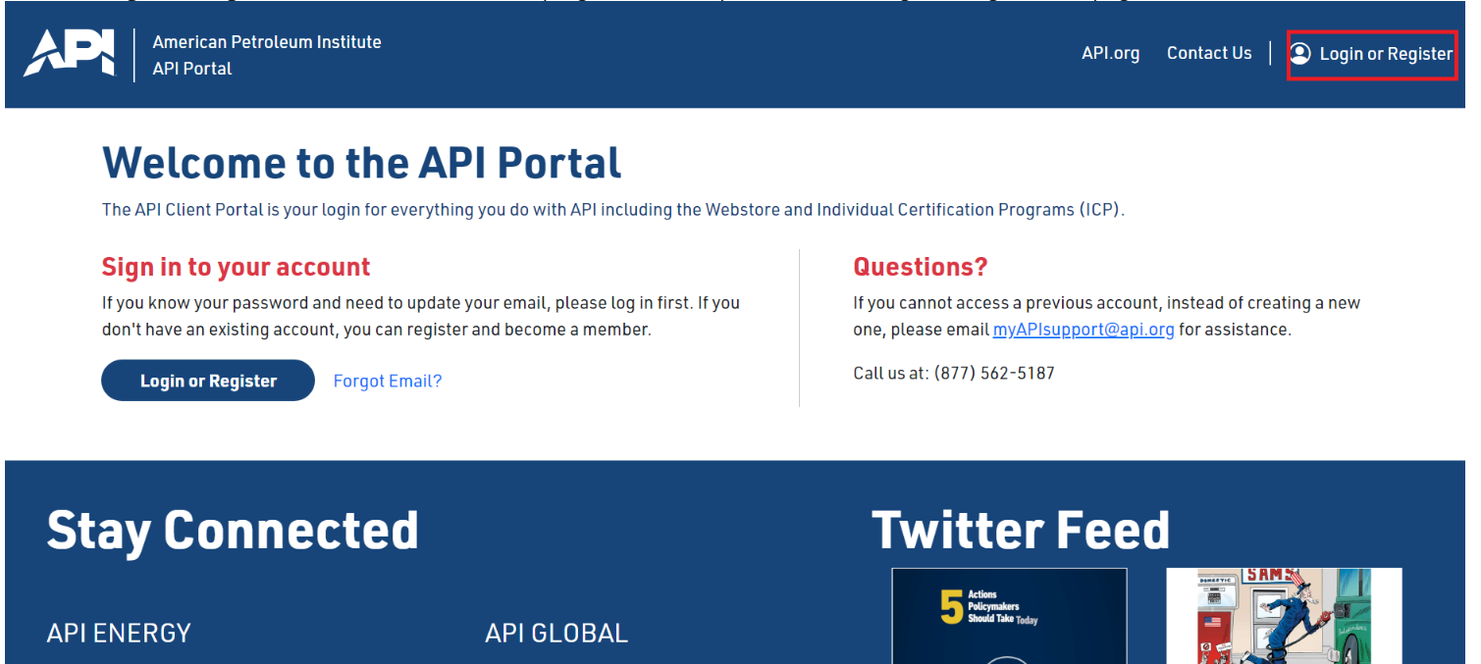

Step 3: Select Registration
- If you do not have an account, select the Register option below the login fields.
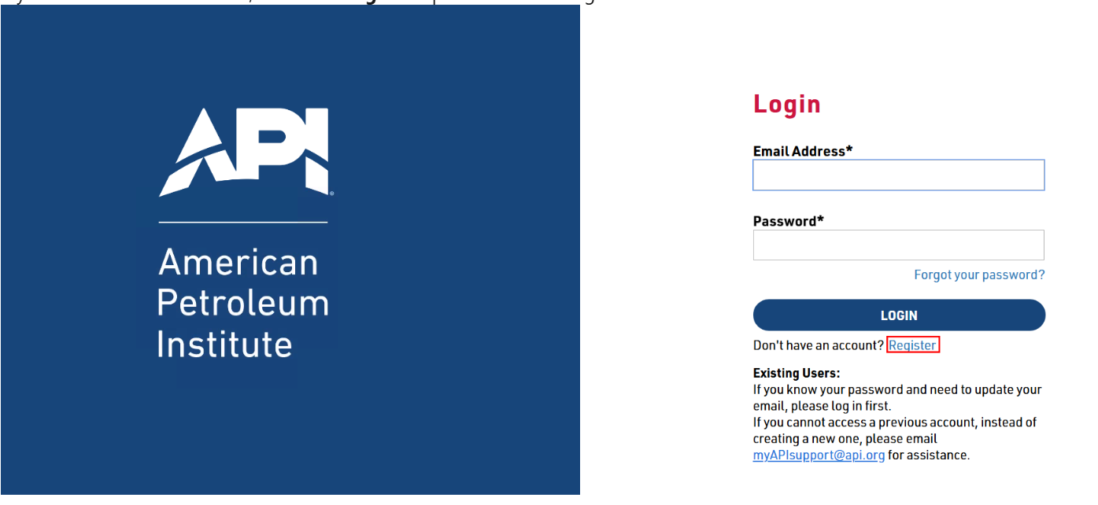

Step 4: Complete the Registration Form
- Fill out the form with the following information:
  - First Name (as shown on your government-issued ID)
  - Last Name
  - Company Affiliation (select Yes or No)
  - Company Name (if applicable)
  - API Member Organization (if the company is a member of the API)
  - Email Address (a verification code will be sent to this email)


Step 5: Verify Your Email
- After entering your email address, click Verify Email.
- Enter the verification code sent to your email in the designated field to proceed.
- Click Continue with Registration after entering the code.
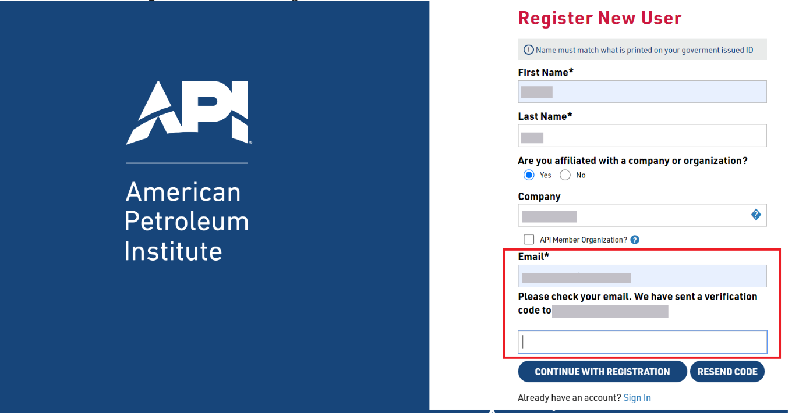
Step 6: Set Your Password
- Once your email is verified, you’ll be prompted to create a password.
- Enter your password, then re-enter it in the Confirm Password field.
- Click Create to save your password.

Step 7: Register Your Phone Number
- After setting up your password, select your country code and enter your phone number.
- Click Send Verification to receive an SMS with a verification code.
- Enter the code you received and click Verify Code to complete phone verification.
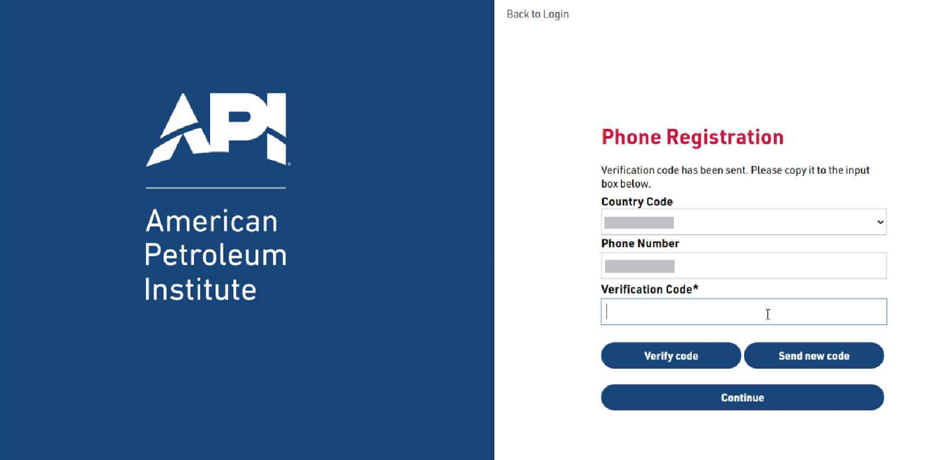
Step 8: Finalize Registration
- After verifying your phone number, click Continue to complete the registration process.
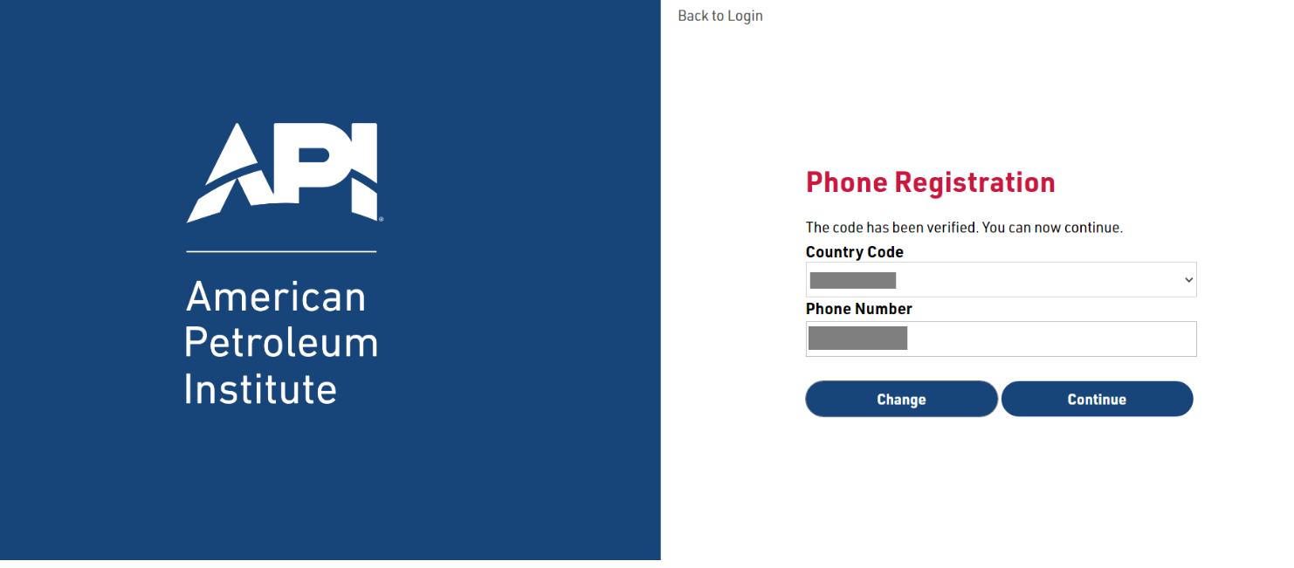

Step 9: Confirm Account Creation
- Once registration is complete, you will be redirected to your Dashboard.
